**Purpose:**

The purpose of this standard operating procedure is to walk you, the user, through the joint measurement analysis (JMA) toolbox. This toolbox will allow you to import bone models (.stl files) and calculate joint space distance and congruence index at correspondence particles. These correspondence particles can easily be created from ShapeWorks.

**Scope:**

**Notes:**

**Programs Used:**

Statistical Shape Model from <http://sciinstitute.github.io/ShapeWorks/latest/>

SPM Toolbox from <http://www.spm1d.org/install/InstallationMatlab.html>

MATLAB from <https://www.mathworks.com/>

Parallel Computing Toolbox

Statistics and Machine Learning Toolbox

**Pre-requisites:**

Correspondence particles from a statistical shape model (.particles file)

Bone models or reconstructions (.stl files)

Kinematic data (if desired) from biplane fluoroscopy or other motion capture (.txt files)

Normalization frames (if desired) from biplane fluoroscopy or other motion capture (.xlsx or .csv)

**Table of Contents**

**Workflow** 3

**1.** **Statistical Parametric Mapping (SPM) Toolbox** 4

**2.** **Participant Files** 5

**3.** **Study Group Files** 8

**4.** **Data Consolidation** 10

**5.** **Test Case Dataset** 12

**6.** **Processing Data – JMA_01 Mapping Data** 13

**7.** **Processing Data – JMA_01a Import User Data** 15

**8.** **Processing Data – JMA_02 Normalize Data** 16

**9.** **Processing Data – JMA_03 Stats** 17

**10.** **JMA_03 – Figure Settings** 25

**11.** **Interpreting Results – Location** 29

**12.** **Frequently Asked Questions – FAQs** 32

**Procedures:**

# **Workflow**

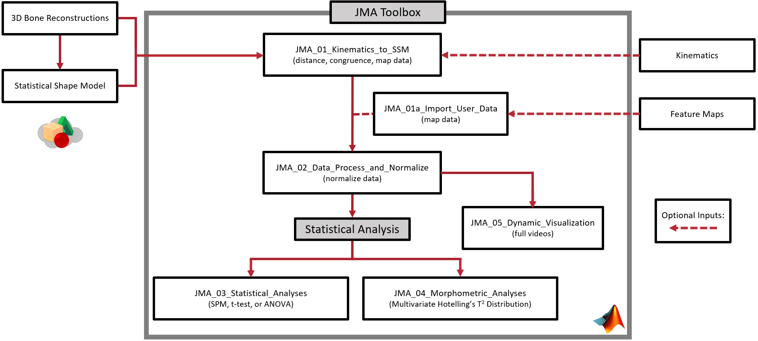

# **Statistical Parametric Mapping (SPM) Toolbox**

* 1. Download the spm1D package (<https://spm1d.org/>), extract wherever you need, and then add the package to the MATLAB path. This will allow the spm1D package to be called upon from any function or script without needing to be in the same file path.

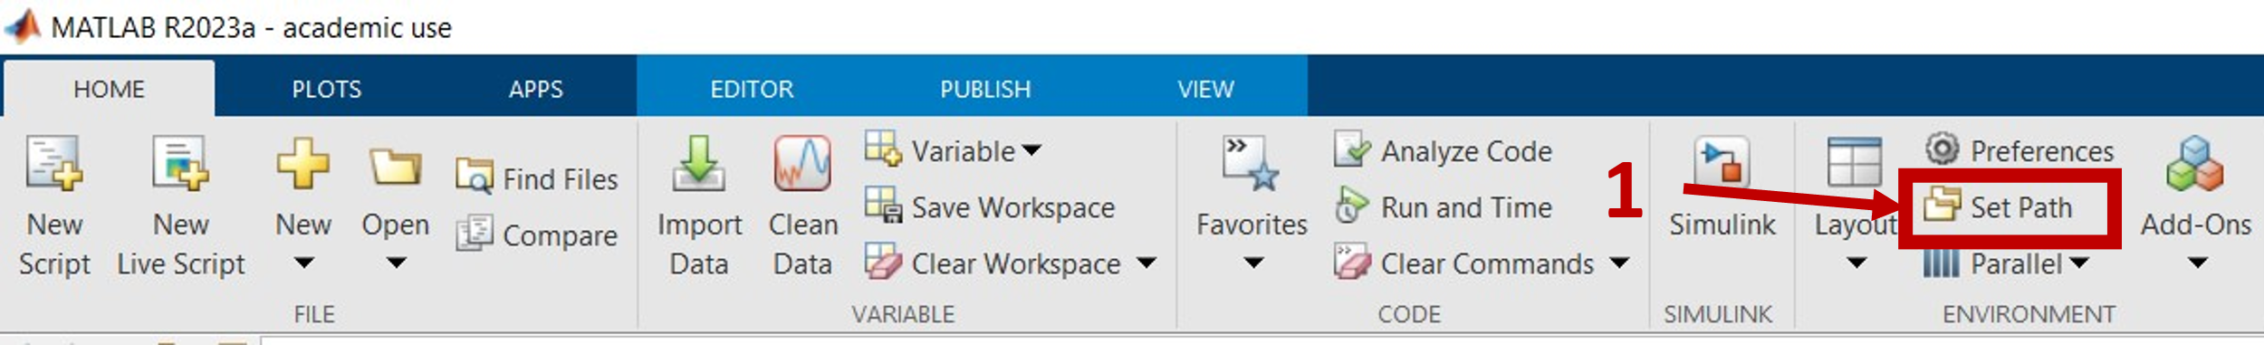

*MATLAB > Home > Set Path (1)*

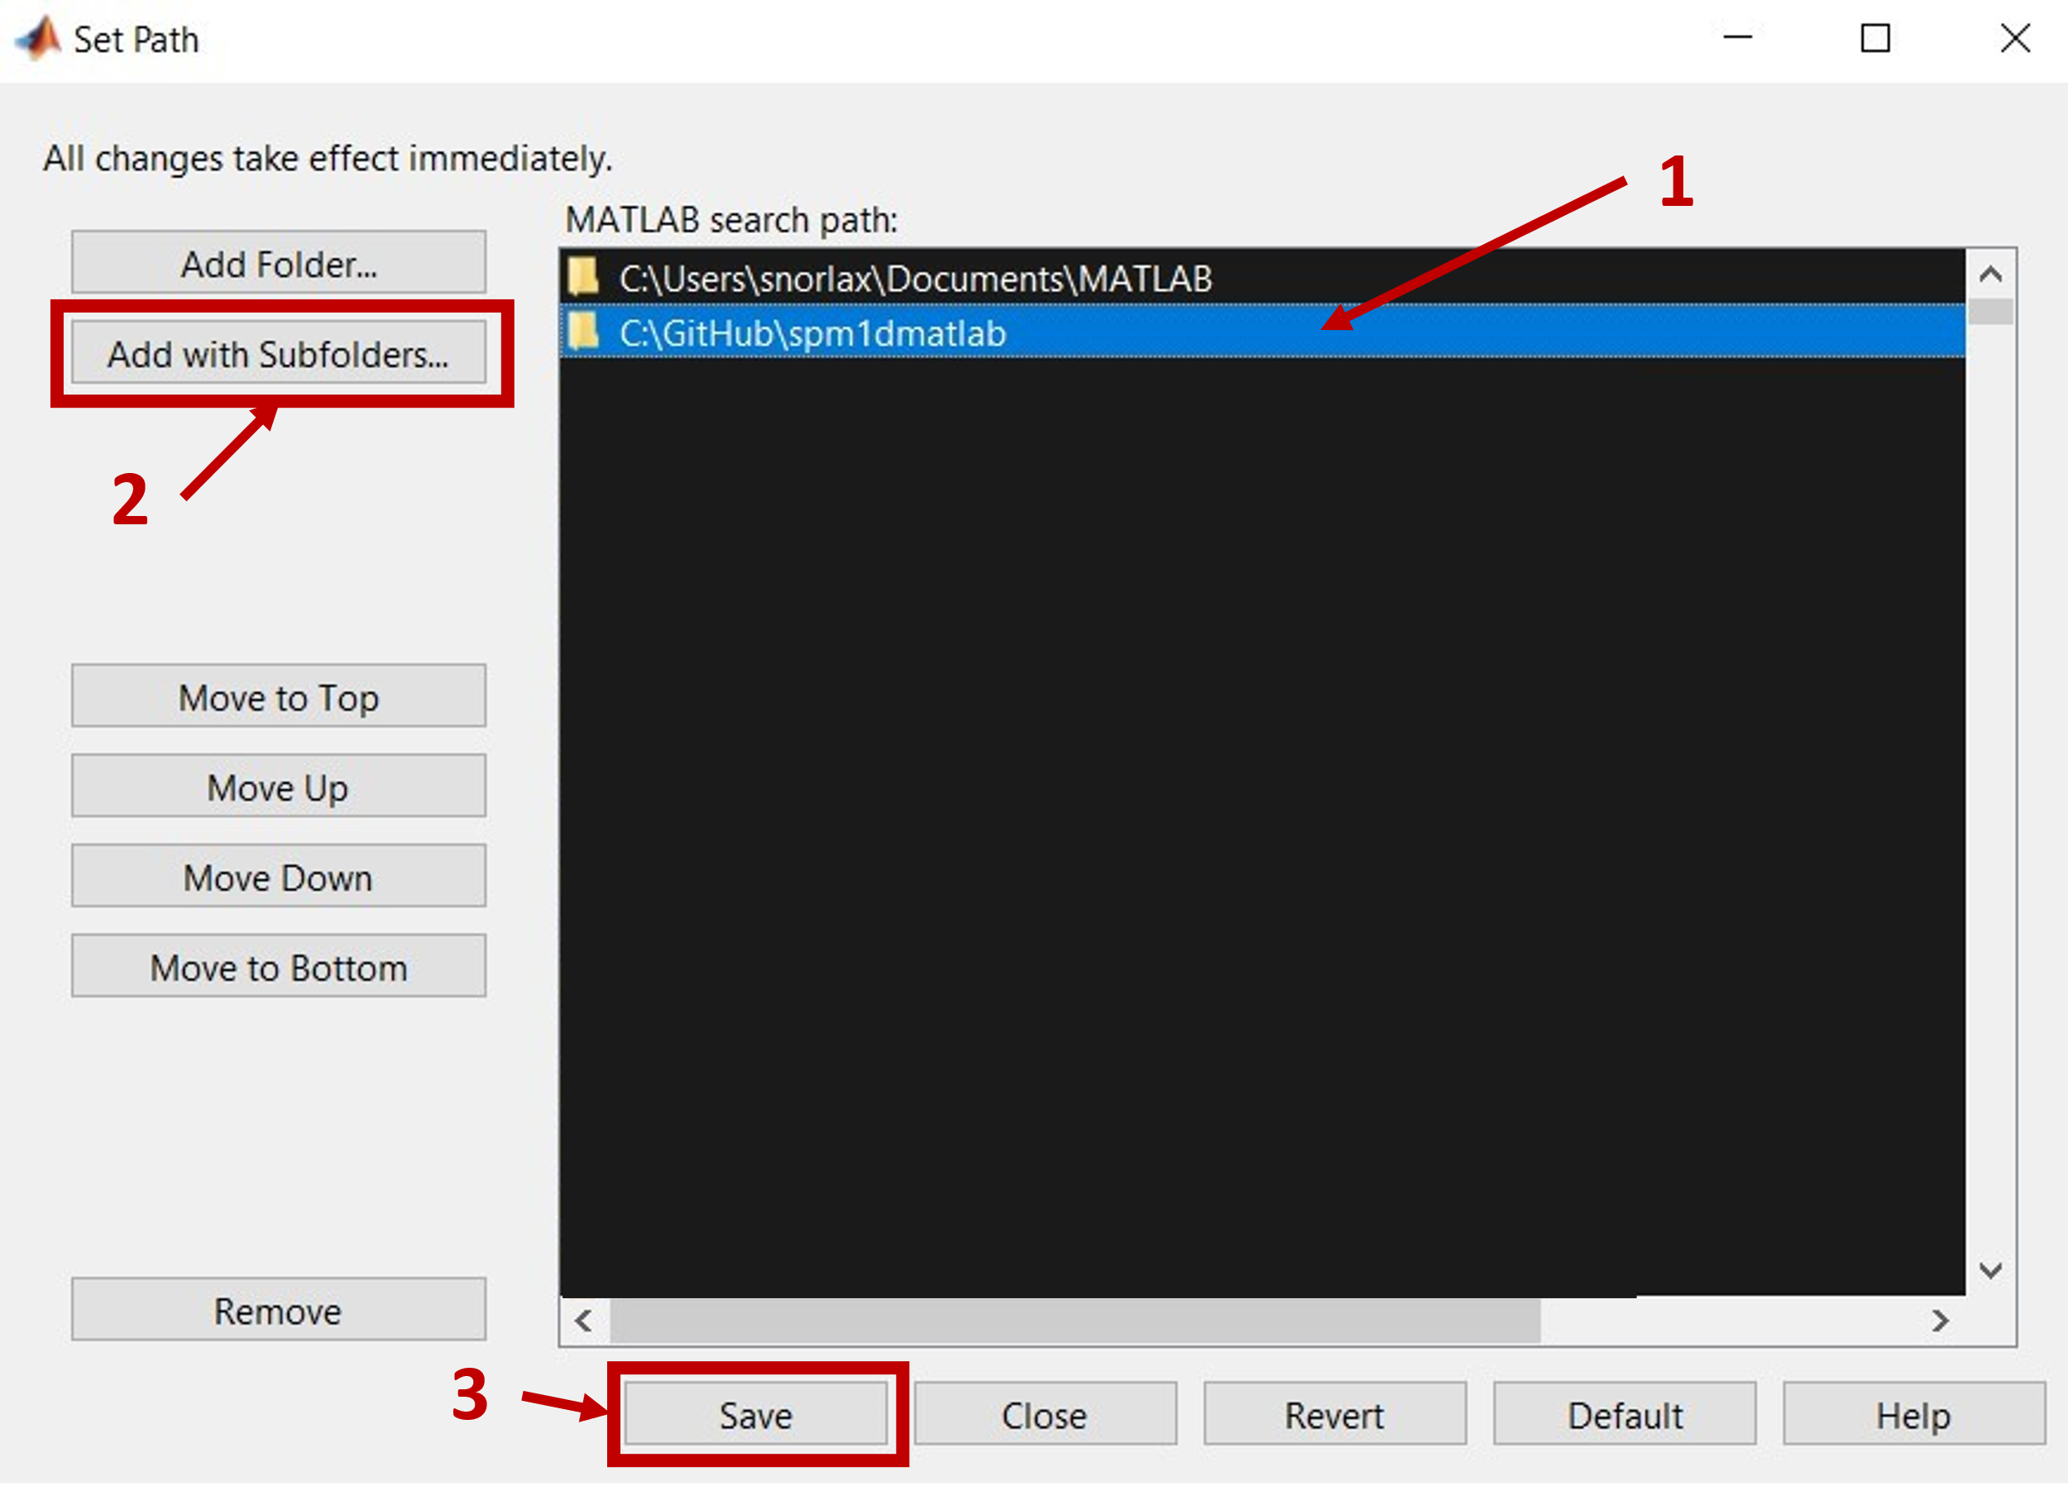

*Select the folder location (1) > Add with Subfolders… (2) > Save (3)*

# **Participant Files**

* 1. **Creation of participant-specific files:**

In order to run the JMA you will need to have several specific files for each participant placed in a nested folder. The idea is that these folders are created so it should be easy point and click to run. You will only need the Event spreadsheet and kinematic text files if you are conducting a dynamic analysis using the toolbox.

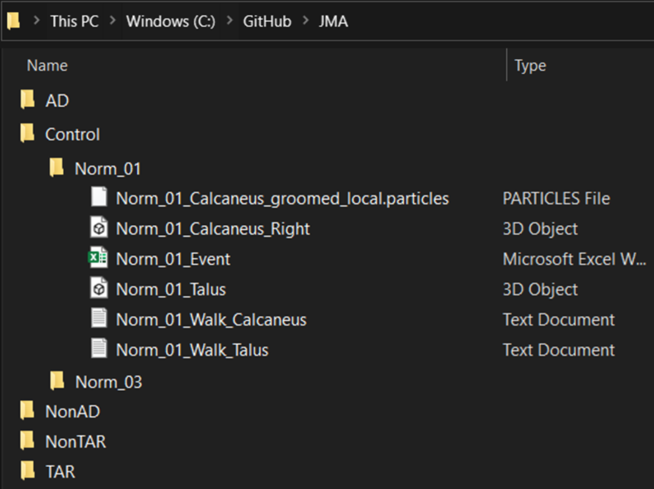

* 1. **Kinematic files** (.txt)
     1. **Purpose:** The kinematic files contain bone-specific 4x4 transformation matrices for each frame (or time point) of a tracked activity. The purpose of this is to transform the bone models to their tracked location for each frame. ***This file is not necessary for single time point static JMA.*** If the .txt file is not within the participant-specific folder the script will assume a static single time point and will automatically proceed using an identity matrix.
     2. **Naming Convention:** In order for this script to load the data properly it just needs to have the name of the bone within its filename. The spelling needs to be consistent and specific as one of the user inputs of the JMA_01 script is the names of the bones.
     3. **Format:** Within the file each row is a single frame or time point and there are 16 columns. Every four values are a row of the 4x4 matrix. For example, when constructing an identity matrix in this format it will look like this: [**1,0,0,0,0,1,0,0,0,0,1,0,0,0,0,1]** with each color denoting a different row.
  2. **Event files** (.xlsx or .csv)
     1. **Purpose:** The event file is for truncation and normalization of the data to percentage of the activity. From the test dataset it is from heel-strike to toe-off. ***This file is not necessary for single time point static JMA or if you do not have specific events that you would like to normalize to.*** If you would like to normalize to the tracked activity and have provided a kinematic file that is longer than one time point, then by not including this file it will normalize to the length of the kinematic file (i.e., the length of the activity).
     2. **Naming Convention:** In order for this script to load the data properly it just needs to have the name of the bone within its filename. The spelling needs to be consistent and specific as one of the user inputs of the JMA_01 script is the names of the bones.
     3. **Format:** Within the file it will have a single row and 4 columns. It will be truncated to common percentages of the normalized activity from the first tracked frame to the last tracked frame. The frame selected for heel-strike frame will be 0% and the frame selected for toe-off frame will be 100% of the normalized activity. From the test dataset the excel sheet will have [**first tracked frame, heel-strike frame, toe-off frame, last tracked frame**].
  3. **Bone files** (.stl)
     1. **Purpose:** The bone models are the surfaces that the distances and curvatures will be calculated from. These bone models should be smoothed, decimated, and the mesh resolution constructed to your needs. It is recommended that you mesh with edge lengths that result in a high-resolution mesh, as a sparse mesh will lead to erroneous measurement calculations. For example, the test dataset each bone was meshed with a maximum edge length of 0.5 mm and then smoothed to eliminate rough triangle edges. The coordinate space of these bone models should be those that match the kinematic transformation matrices.
     2. **Naming Convention:** Each of the bone .stl files will need to have the name of the bone in the filename. The spelling needs to be consistent and specific as one of the user inputs of the JMA_01 script is the names of the bones. So, if there are any variations or inconsistencies from what you input into JMA_01 you will have issues and the files will not properly load. For any specific joint analysis at least one of the .stl bone files of that joint will need to have the laterality of those bones included in the name. This can be done by including “_right_”, “_left_”, “_R_”, or “_L_” (upper or lower case it doesn’t matter) somewhere within the file name. For example, if you were running JMA on the subtalar joint, as in the test dataset, you will need to include the laterality in either the talus or the calcaneus .stl filenames, *ParticipantID*_Talus_left.stl. If no laterality is included in either of the .stl filenames it will be assumed that they are a right sided limb. Laterality is needed as the kinematic files are likely not reflected to match the reflection of the bones needed for a good correspondence model within ShapeWorks (right is the assumed convention here).
  4. **Correspondence Particle files** (local.particles)
     1. **Purpose:** The correspondence particle files for each participant are outputs from ShapeWorks and can be found within its project file. The world.particles particle locations are on the surface of the models from the groom steps. The local.particles particle locations are on the surface of the models when they are imported into ShapeWorks. This toolbox uses the **local.particles** and aligns the bone model to their respective correspondence particles using an iterative closest point algorithm in order to pair bone model surface nodes to the correspondence particles. If you ran Procrustes on your shape model and insert world.particles into the participant-specific folders, you will run into issues. Namely it will not map correctly because of difference in scale and JMA_01 will crash. Verify that you are using the correct particle files and bone model .stl files.
     2. **Naming Convention:** In order for this script to load the data properly it just needs to have the name of the bone within its filename. The spelling needs to be consistent and specific as one of the user inputs of the JMA_01 script is the names of the bones.

# **Study Group Files**

**Creation of group files (Mean_Models folder):**

* 1. **Bone files** (.stl)
     1. **Purpose:** The mean shape of a study group is used for creating figures showing the joint space results. See the figure below for example of how to locate where to export the mean shape for a specific group. From this same place you can also export the correspondence particles for that study group mean shape. (See below figure for example)

*ShapeWorks > Analyze > Group Set (1) > Group (2) > Mean (3) > File > Export > Current Mesh*

* + 1. **Naming Convention:** In order for this script to load data properly it just needs to have the name of the bone and the study group within its filename separated by underscores (e.g., *Mean_StudyGroup_BoneName.*stl).
  1. **Correspondence Particles** (.particles)
     1. **Purpose:** The mean shape of a study group is used for creating figures showing the joint space results. See the figure below for example of how to locate where to export the mean shape for a specific group. From this same place you can also export the correspondence particles for that study group mean shape.

*ShapeWorks > Analyze > Group Set (1) > Group (2) > Mean (3) > File > Export > Current Particles*

* + 1. **Naming Convention:** In order for this script to load data properly it just needs to have the name of the bone and the study group within its filename separated by underscores (e.g., *Mean_StudyGroup_BoneName.*particles).

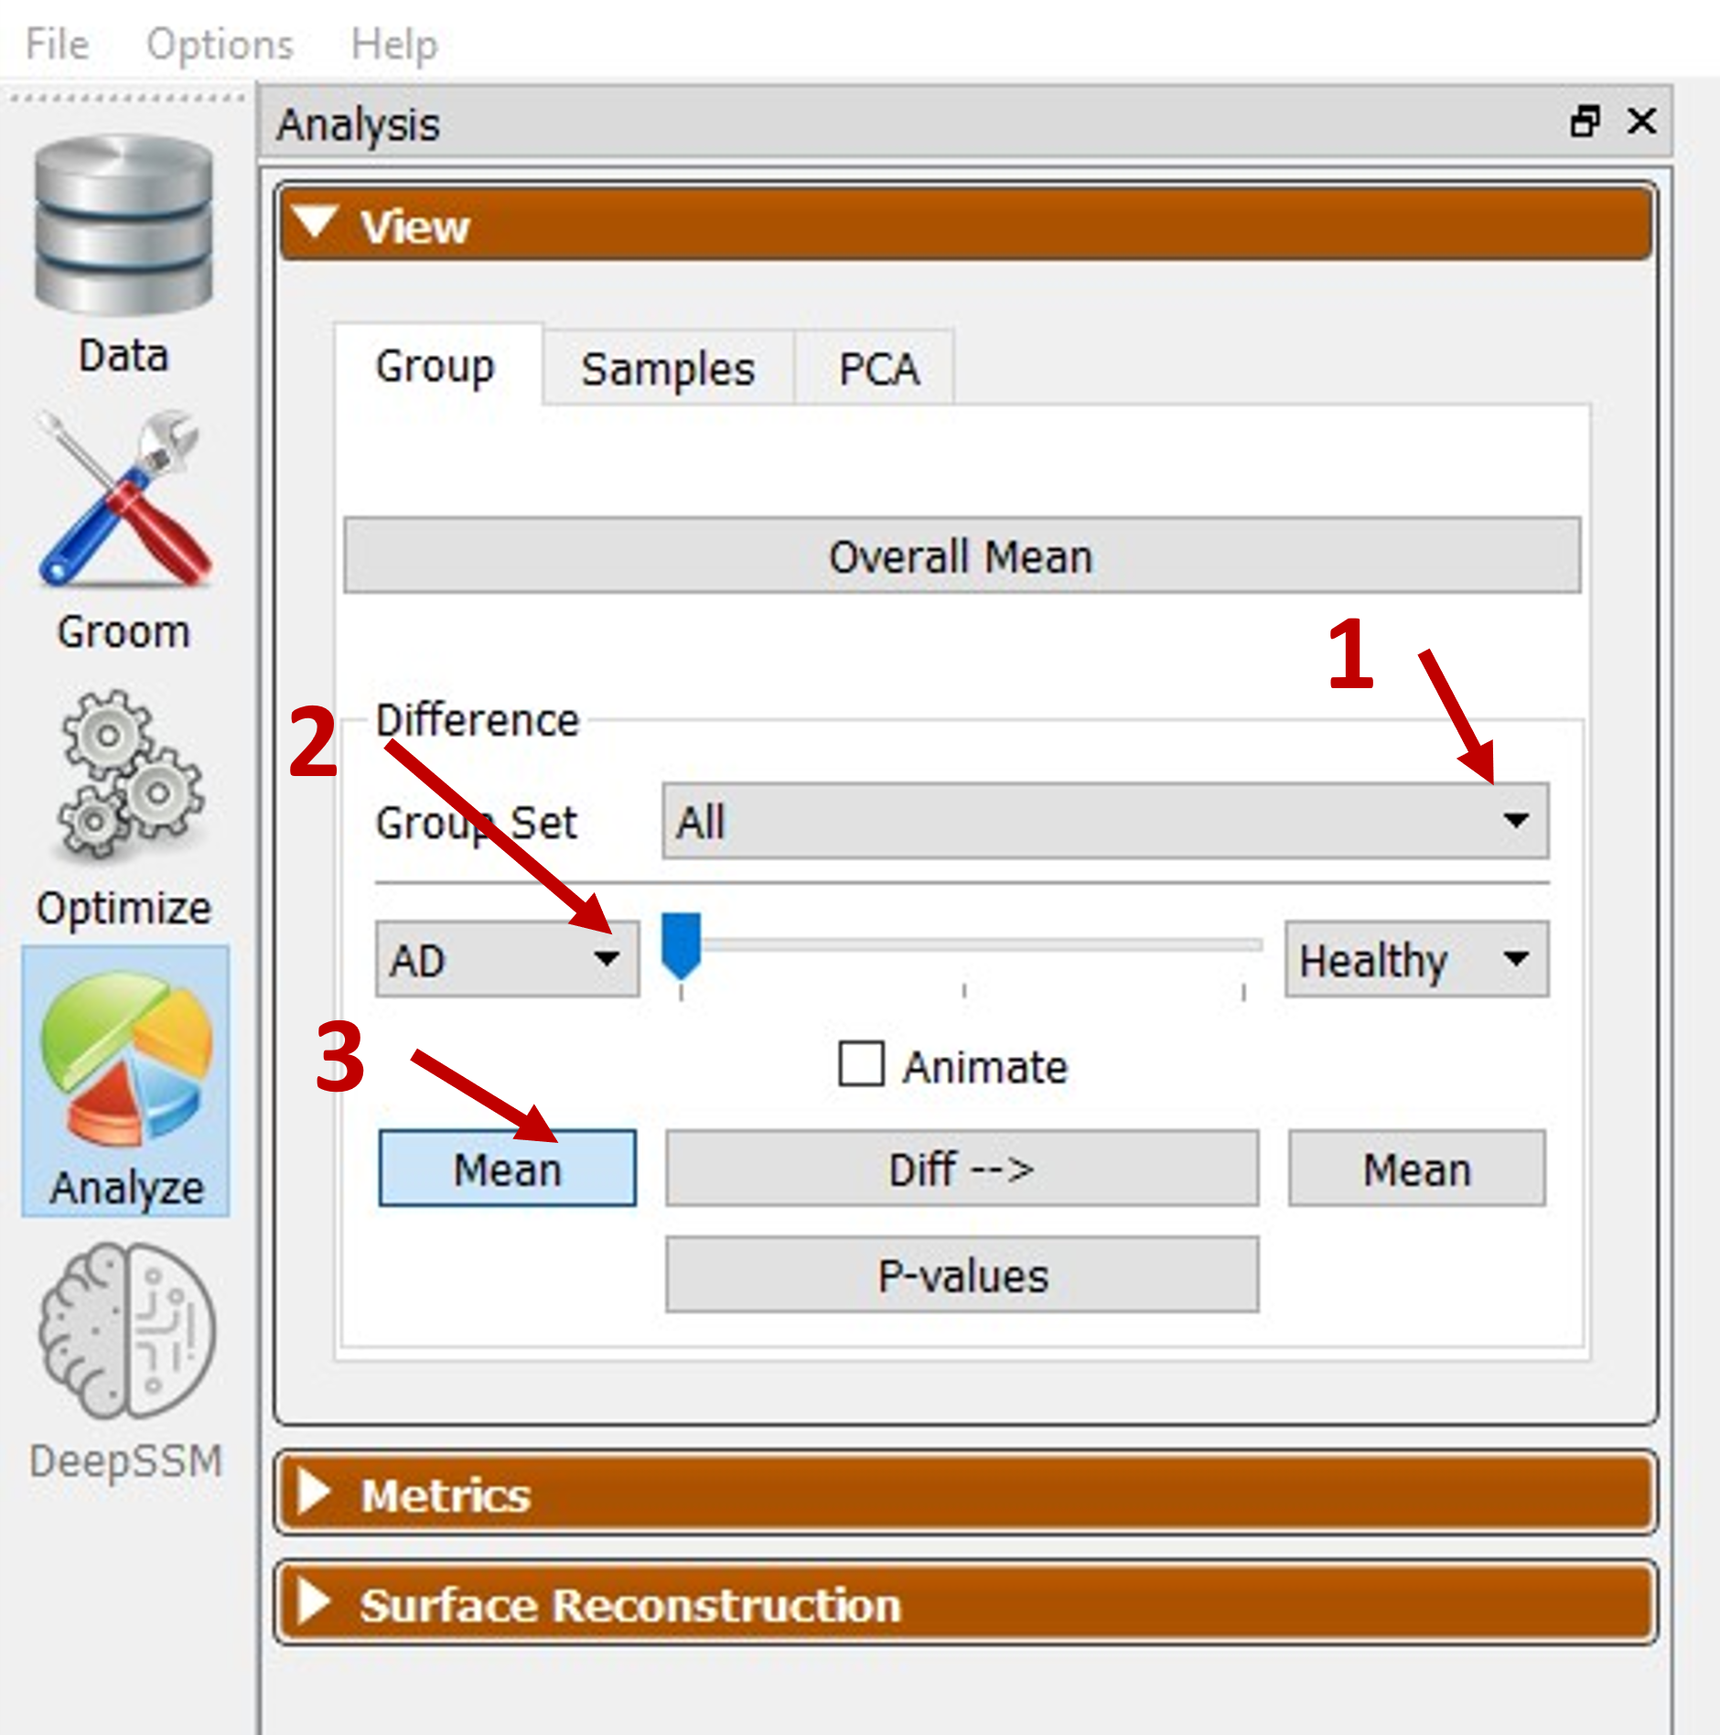

# **Data Consolidation**

**Consolidate data for each participant:**

* 1. The JMA Toolbox operates out of a project directory and therefore you will need to copy/move files into folders within that location to be able to proceed. It is suggested to place outside of the JMA directory so that your data is not deleted by GitHub when pulling any future releases. A test case dataset has been included within the toolbox GitHub repository as an example. Please see below section **Test Case Data** for more information on the included dataset.
  2. The JMA Toolbox utilizes study group folders with nested participant-specific folders to load and save data (see below figure). Each study group will have its own folder (e.g., Controls, Pathologic, etc.) and nested within each of those folders will be that study group’s participant-specific folders containing the necessary files. The name of the study group folder (AD, Control, NonAD, etc.) and the name of the participant-specific folders dictates the names of the data structures used in the MATLAB script. A few things to note, the names should not start with numbers as this will cause the scripts to crash (cannot be structure names starting with numbers), cannot include hyphens or dashes (‘-‘), and the participant-specific folders do not need to match the study group folder name. The scripts will check each folder directory for specific file types and query the filename for identifying naming conventions (listed above in section 2) which includes the bone name and laterality.



* 1. **Importing your own data:**

If you want to import your own data to be compared at the correspondence particle locations, you just need to add an .xlsx or .csv file of the participant-specific data into their respective folders. Please refer to section 7 for more information.

# **Test Case Dataset**

**Test Case Dataset:** The test case data provided includes three individuals surgically treated with tibiotalar arthrodesis and their untreated contralateral limb (AD_02, AD_04, and AD_10), two individuals surgically treated with total ankle replacement and their untreated contralateral limb (TAR_04 and TAR_06), and two healthy asymptomatic controls (Norm_01 and Norm_03). The data for each of these participants is in participant-specific folder within their respectivegroups.

# **Processing Data – JMA_01 Mapping Data**

**Processing Data:**

* 1. **JMA_01_Kinematics_to_SSM.m**
     1. **Disclaimer:** This script will take the longest to run and is the most computationally expensive portion of the JMA process. Depending on your computer you will have varying computational times. The machine used for processing the data for the manuscript had an AMD Ryzen 9 5950X 16-Core Processor and 64 GB of DDR4-32000 RAM. With 16 workers it took on average 30 seconds per frame (excluding the first frame) to calculate the joint space measurement data. Future work may implement further developments for optimizations and reduce computational time. The number of faces on each of the surface files is what greatly affects this.
     2. **Running the Script:** After arranging the files into the appropriate folder structures you are ready to start processing some data.
* Open and run the MATLAB script JMA_01_Kinematics_to_SSM.m. You will be prompted with a popup asking you to enter user inputs.
* Enter the name of bone that data will be mapped to and therefore visualized on.
* Enter the name of opposite bone – this is the name of the opposing bone that distances from the previous bone will be calculated to.
* Enter number of study groups – this is how many groups you want to process; you can process them separately or consecutively.
* Would you like to overwrite previous data? – If selected it will save over previous .mat files for that specific joint. If selected it will start from the first frame and ignore previous .mat files. If it is not selected it will load any previous .mat files for that joint and continue where it was last saved.
* How often would you like to save the .mat file in case of interruptions? – Every x number of frames will save the structures to a .mat file. Only applies to dynamic and is especially helpful if running for long periods of time and in case of power outage, unexpected software updates, etc.
* Do you want to calculate the surface area on both bone surfaces? – Will calculate the surfaces not only on the mapped bone surface but also on the opposing surface as well. However, it will take double the time as it will need to calculate intersecting surface normal from the opposing surface as well.
* Would you like to save coverage area .stl files for each time step? – Selecting or checking this box will save the coverage surface bone .stl files. Specifically, it will only save the mapped surface unless the surface area on both surfaces are being calculated (from previous input), in which case it will save both surfaces.
* Troubleshoot? – Selecting or checking this box will plot the correspondence particles and bones of each subject so you can verify that everything is properly aligned.
* Set the region of interest bounds when determining surface normals between bones – This sets a distance threshold so that any distance between surface nodes greater than this value will not be included for determining coverage regions. Reduces the computational time necessary for the ray-tracing intersecting normals.
* Do you need to align the particles to the surface meshes? – Selecting or checking this box will run an iterative closest point algorithm using lowest RMSE to align the correspondence particles from local.particles to the surfaces meshes from the .stl files. You only need to select this option if they are in different coordinate spaces from one another.

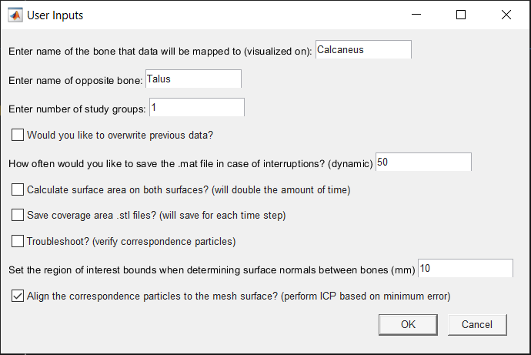

* + - 1. **Location of data:** Nex you will be prompted to select the directory/folder where the data is located. Each script will ask you this so that it can path to the correct location.

# **Processing Data – JMA_01a Import User Data**

**Processing Data:**

* 1. **JMA_01a_Import_User_Data.m**

The JMA_01a_Import_User_Data.m script will load data from spreadsheets and pair to their correspondence particles. The spreadsheets will need to be within each participant specific folder. The structure of this spreadsheet is as follows: the first column is the node indices and the following columns starting at cell B, are the data at that node for each time point. For example, see the figure below. The output structure and file names will be in lower case and will be named the spreadsheet name without the participant-specific identifier. **So, it is important to have the names other than the identifiers be consistent!** For example, if you are running it with FEA results a control participant could be called Control_01 and the FEA data spreadsheet named FEA_Control_01.csv and the outputs for the FEA results will have ‘fea’ in their name rather than ‘Distance’ or ‘Congruence’.

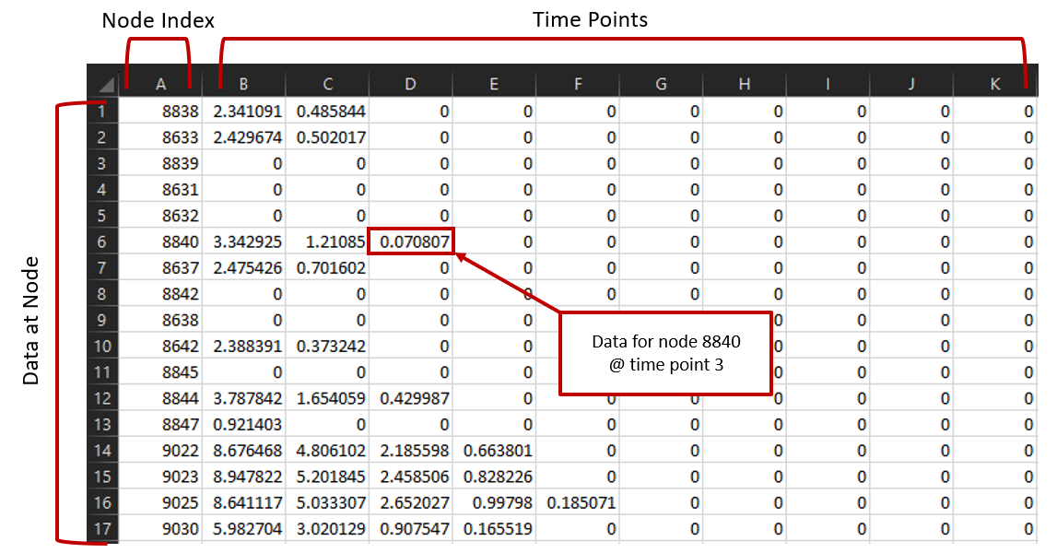

# **Processing Data – JMA_02 Normalize Data**

**Processing Data:**

* 1. **JMA_02_Data_Process_and_Normalize.m**
     1. The JMA_02_Data_Process_and_Normalize.m script will normalize and truncate the data to consistent percentages of stance for the data measured from the JMA_01 script. When you run it, you will be asked to enter the names of the bones and enter the number of study groups then prompted to select the folders just as you did with JMA_01. It is important to note that it will only normalize across those that are selected. I suggest selecting all of your groups so they are consistent, and it will be easier to make comparisons in the stats JMA_03 script.
     2. The results from this script will be stored in a structure and saved as a .mat file with a name starting in ‘Normalized_Data’ within the …\Outputs\JMA_02_Outputs\ folder. The beginning of the file name will be concatenated with the names of the groups processed (e.g., ‘Normalized_Data_Calcaneus_Talus_AD_Control_NonAD_NonTAR_TAR.mat’).

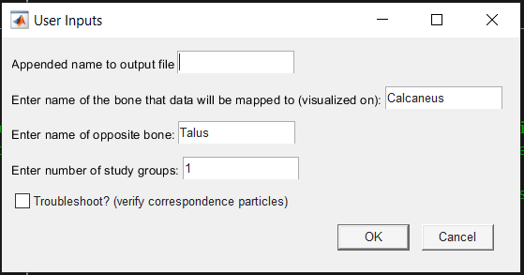

# **Processing Data – JMA_03 Stats**

**JMA_03_Statistical_Analyses.m**

* 1. The JMA_03_Satistical_Analyses.m script has several options for comparing or visualizing results. Each statistical analysis is performed at each correspondence particle and currently is not spatially connected. Options for analysis include Student’s *t-*test and/or Wilcoxon rank-sum test, one-way ANOVA and/or Kruskal-Wallis test, temporal 1D statistical parametric mapping (SPM) analysis, group visualization, or individual participant visualization. ANOVA SPM has not been included to date but will be in the future.

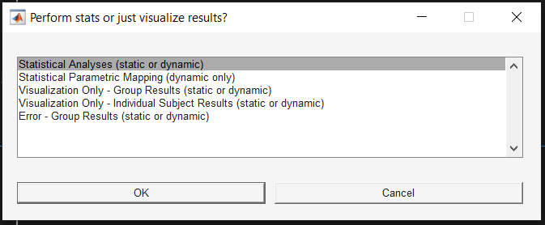

* 1. Statistical Analyses (static or dynamic)

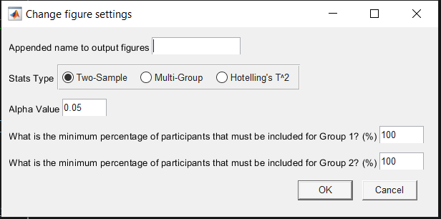

* + 1. Appended name to output figures – Will add any name here to the output files and results. Helpful when running multiple different conditions or figure settings but you don’t want to overwrite previous files.
    2. Stats Type – select what stats type you would like to proceed with
       1. Two Sample: Student’s t-Test and/or Wilcoxon Rank Sum Test
       2. Multiple Group: One-way ANOVA and/or Kruskal-Wallis Test
       3. Hotelling’s *T2* Test
    3. Alpha Value – The alpha value used for each of the statistical tests
    4. Group 1 minimum – if set to 100% then for a specific correspondence particle’s comparison it will need to have data mapped for each subject of the first group in order to be included in the analysis.
    5. Group 2 minimum – similar to the group 1 minimum but for the second group instead.
  1. Statistical Parametric Mapping (dynamic only)

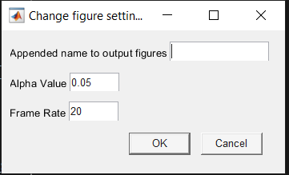

* + 1. Appended name to output figures – Will add any name here to the output files and results. Helpful when running multiple different conditions or figure settings but you don’t want to overwrite previous files.
    2. Alpha Value – The alpha value used for each of the statistical tests
    3. Frame Rate – the frame rate for the dynamic videos (stitches figures together)
  1. Visualization Only – Group Results (static or dynamic)

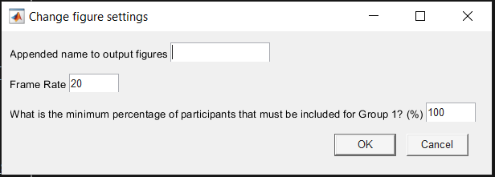

* + 1. Appended name to output figures – Will add any name here to the output files and results. Helpful when running multiple different conditions or figure settings but you don’t want to overwrite previous files.
    2. Frame Rate – the frame rate for the dynamic videos (stitches figures together)
    3. Group 1 minimum – the minimum percentage of participant’s data mapped to a correspondence particle in order for that particle to be visualized.
  1. Visualization Only – Individual Subject Results (static or dynamic)

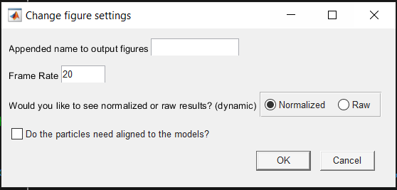

* + 1. Appended name to output figures – Will add any name here to the output files and results. Helpful when running multiple different conditions or figure settings but you don’t want to overwrite previous files.
    2. Frame Rate – the frame rate for the dynamic videos (stitches figures together)
    3. Normalized or Raw? – Visualize the normalized data from JMA_02 for that participant or visualize the raw data from JMA_01
    4. Align particles and models? – Do the correspondence particles need to be aligned to the 3D model? Same as JMA_01 alignment.
  1. Error – Group Results (static or dynamic)

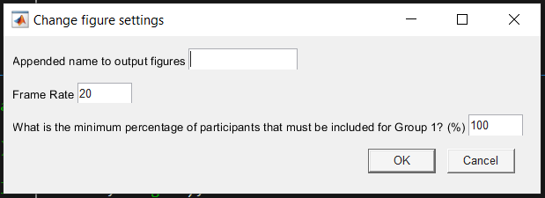

* + 1. Appended name to output figures – Will add any name here to the output files and results. Helpful when running multiple different conditions or figure settings but you don’t want to overwrite previous files.
    2. Frame Rate – the frame rate for the dynamic videos (stitches figures together)
    3. Group 1 minimum – the minimum percentage of participant’s data mapped to a correspondence particle in order for that particle to be visualized.

For error you will be asked to select the measured data and then select a feature map that you have included as the accepted measurement. The measurement percent of error will then be calculated for each particle.

* If any option other than SPM or individual results was selected, you will be prompted to enter the minimum percentage of participants that must be included for each group. What this is asking is if you want to include in the analysis any correspondence particles that do not have data for each participant within a group. In short, reducing this percentage will likely increase the number of particles visualized, but may not have results for each participant. This is likely due to morphology or kinematic differences. When making comparisons with SPM, to be included, a particle must have data for each participant or SPM will not work properly. The other comparisons on the other hand are not connected or corrected across time and are handled on a frame-by-frame basis. Therefore, you can set the threshold for the minimum amount of data needed at a particle to be included. It is important to note that there is a minimum of 5 participants within each group needed in order to perform a Shapiro-Wilk normality test.
* Would you like to include multiple results (more than one bone, or one bone with multiple results mapped)? This option allows you to visualize multiple results on the same figure. The limit thresholds will be applied across all results. See examples below.

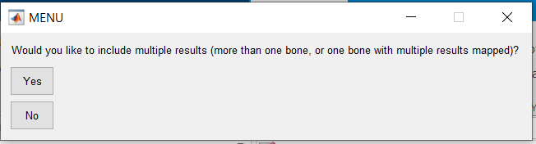

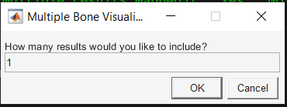

* + Example multiple results on one bone (Calcaneus: Subtalar and Calcaneocuboid joints):

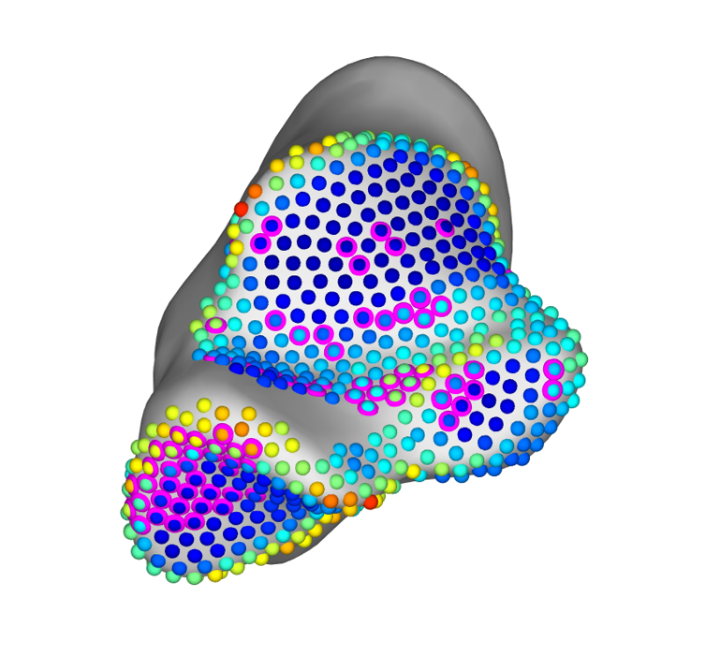

* + Example results on multiple bones (Tibia: Tibiofibular joint, Talus: Talofibular joint):

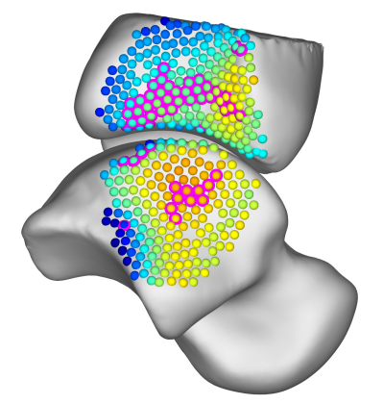

* 1. **Running the script: Selecting and loading .mat file**

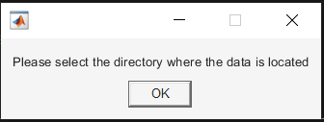

Select the project directory.

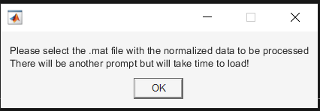

Then select the .mat file(s) with the normalized data to be processed. It will have the title Normalized_Data_*BoneName1_BoneName2_StudyGroup1_...StudyGroupN*.mat. The field *BoneName1* is the bone with the correspondence particles and *BoneName2* is the opposing bone. It will then list off the groups included in the .mat file. This is so that multiple variations can be run and saved from the same directory depending on your needs.

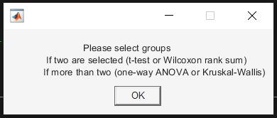

If not SPM, then you will be asked to select groups. Select all of those that you wish to include (if only two are selected it will perform t-test or rank-sum, if more than two are selected it will perform ANOVA or Kruskal-Wallis test). Otherwise, if SPM you will be asked to pick the two groups to perform the comparison on.

* 1. **Running the script: Selecting first group to compare**

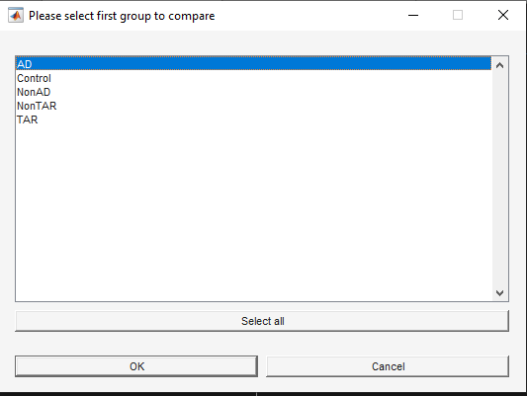

The first group to compare is which study group bone model will be used and that group’s mean results will be displayed on the bone model. Select the first group and select “OK”.

* 1. **Running the script: Selecting the second group to compare**

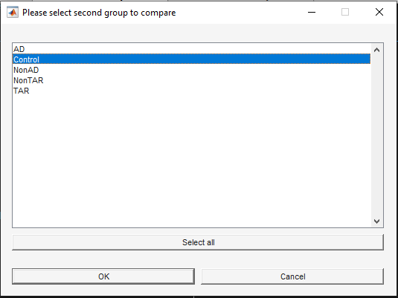

The second group to compare is which study group the first group will be compared against. If measurements at a correspondence particle are statistically significant (p<0.05) they will be circled in pink. Select the second group and select “OK”.

* 1. **Running the script: Select which data to analyze**

Select which data you would like to analyze, if more than one is selected (using shift or control click) you will process each of those selected. **NOTE: The colormap and figure settings will be the same for each. It may be beneficial to run separately.**

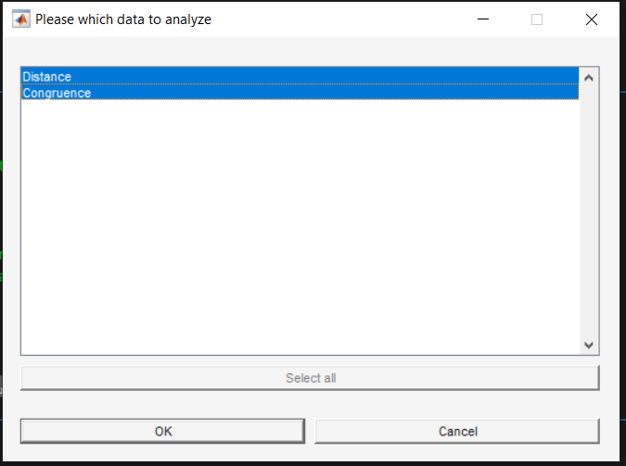

The default is if any results at any particle are nonparametric it will default to only show nonparametric results. However, by choosing to combine the analyses onto the same plot it will show both parametric and nonparametric results. Meaning, that it will not omit parametric results. Since the normality test is performed at each particle some may be found to be normal while others are not. Obviously, if the results at a particle were found to be nonparametric only the nonparametric test results will be visualized for that particle, and vice versa.

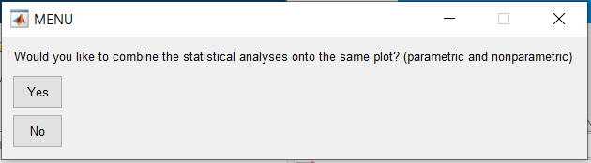

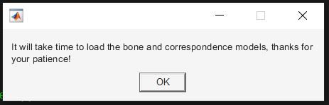

# **JMA_03 – Figure Settings**

**Changing/Loading Figure Settings:**

* 1. **Loading figure settings:** You will not be given the option to load figure settings until you have saved them. Once populated in …\Outputs\JMA_03_Outputs you will be able to load previous settings.
  2. **Randomized data for visualization:** When configuring the figure settings, the correspondence particles are all those that have any data mapped to them, and the data at the particles are randomly created using a Gaussian distribution and some are randomly selected as statistically significant so you will be able to see what it will look like. Your data is not used as it has not had the stats performed on them yet. **Do not panic, these are for visualization only.**

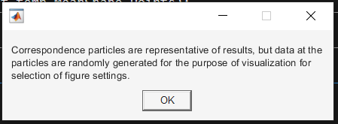

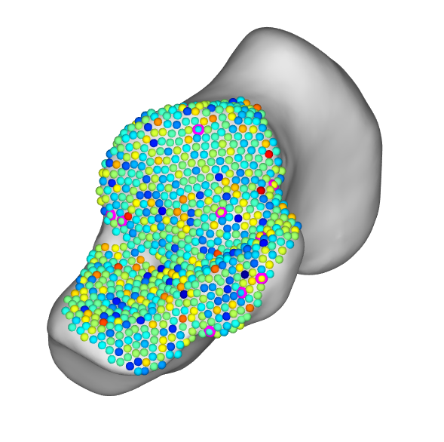

* + 1. Once the figure is generated you will be given the option to modify the figure settings, proceed with the current settings, or proceed and save the current settings.

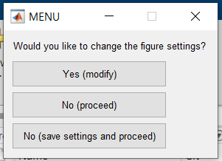

* + 1. If you choose to modify the figure settings a menu will pop up with several options. Every time you select OK it will reload the figure with the new settings and give you the option to proceed or not. You can iterate and change the settings as much as you would like until you are ready to proceed.

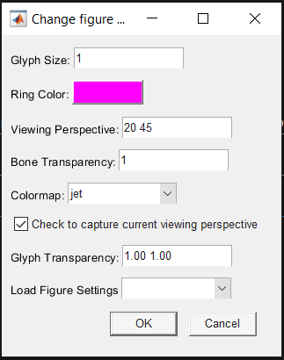

* + - 1. **Glyph Size:** Scale the correspondence particle and ring glyphs
      2. **Ring Color:** Click to bring up several options. The two on the top right let you toggle between standard colors and custom colors (can enter RGB values here).
      3. **Viewing Perspective:** The two values are the figure perspective when it was populated. If the “capture current viewing perspective” is unchecked, you can manually enter values here to change to that perspective. MATLAB’s rotation within a 3D figure is not great and can clip. If this happens you may need to manually manipulate the .stl and .particle files for visualization externally and then reload them.
      4. **Bone Transparency:** Each of these values (currently showing one because only one bone is visualized) is a scalar for the transparency of that bone. The order is based on the order you selected from the .mat files.
      5. **Colormap:** Dropdown that lets you pick some default MATLAB colormaps. Note: if you do not see one that you would like to use, select “type in your own” and enter the name. An option to upload your own colormaps will be added in a future release. You can also type in any of the colormaps from the MATLAB file exchange package: <https://www.mathworks.com/matlabcentral/fileexchange/120088-200-colormap> as these are also included.

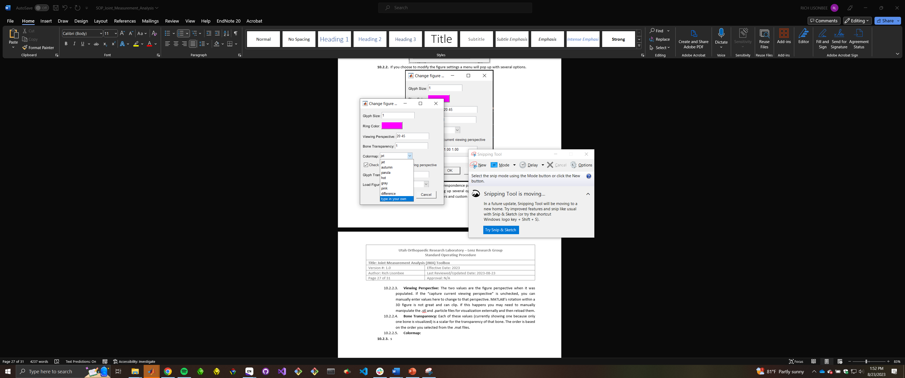

* + - 1. **Check to capture current viewing perspective:** If this is checked when you select OK it will save the current viewing perspective of the figure.
      2. **Glyph Transparency:** Adjusts the transparency of the particle and the ring.
      3. **Load Figure Settings:** Dropdown that if any are selected will load them when you select OK. If you do not want to load any keep it as blank.
    1. **Changing Limits:** For each of the data you wish to analyze you will be able to set the colormap limits and flip the colormap. For example, below shows the Distance data limits. Note that it is Distance followed by the mean and the ±2 standard deviation. The editable field for distance is default set to 0 to 6 mm, while congruence index is set at 0 to the mean +2 standard deviations, and all other user loaded feature maps are -2 standard deviations and +2 standard deviations from the mean.
    2. **Set distance limits for removing particles from analysis:** The default is set at 0 to 6 mm. These values give the lower and upper limit. When performing the stats, any data will only be included if the distance results at that particle for that individual are within these distance limits. This allows you to control what is included in the analysis as any results at a distance of 12 mm for example is likely too far away to realistically be in articulation and therefore should not be included in the analysis. These ranges may change from joint to joint and it is up to you to make the best call of what thresholds you should set.

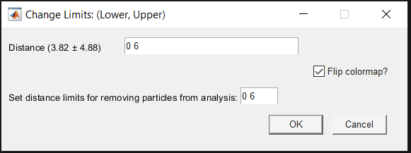

# **Interpreting Results – Location**

**Interpreting Results:**

* 1. **Finding the results:** All of the figures and videos created are saved in the “Results” folder. Within the Results folder there will be multiple folders created as you process and analyze data.
     1. Naming conventions:

*Comparison_Data_Bone1_Bone2_Extra*

Comparison: Name of the statistical test performed, or if no stats labeled as group or individual

Data: Distance, Congruence, or user imported name (fea, dea, etc)

Bone1: Bone data is visualized on

Bone2: Opposite bone

Extra:

_diff if “Difference” colormap was selected

_NonParametric if only nonparametric results were shown

_Parametric if only parametric results were shown

_combined_*BoneName­* if a multi-result figure was created

* + 1. Data name is the name of the data structure (Distance, Congruence, etc.)
    2. Lastly the joint. The joint will be named by the two bone name inputs from the User Input prompt when it was executed. The first bone name is the bone with the data mapped correspondence particles and the second bone name is the opposing bone.
  1. Each stack of .tif images are saved into their respective folder and the .mp4 video will be saved one directory up of the location of the images used to create that video.

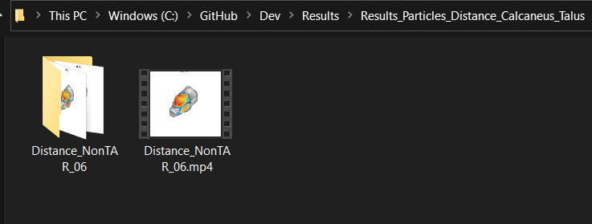

* 1. **Data structures:** Each of the output files are located in the “Outputs” folder and will have a specific folder for JMA_01, JMA_02, and Coverage_Models. The .mat files in the JMA_01 folder will contain compiled raw data from each participant. The .mat files in the JMA_02 folder will have the truncated and normalized data for each participant and group within it. The .mat files in the JMA_03 folder are the saved figure settings.
     1. **Coverage Models**

Each of the models for both bones will be saved following similar architecture within the SOP. Within the Outputs directory there will be a Coverage_Models folder. Nested within the Coverage_Models folder are the folders of each participant with saved coverage models, and they will be named following the *Bone1* and *Bone2* format and within their respectively named folders. **Note that these surface coverage models are created by intersecting normal calculations between the two full bone models**.

* + 1. **Coverage Area Results**

The coverage area results are saved to a spreadsheet following the bone name conventions used in every other output filename. The location of these spreadsheets are within the JMA_02_Outputs directory. Each row is the surface area calculated at that frame. **Note that these surface area calculations are not normalized to percentage of the activity.**

* + 1. **JMA_02 .mat results**

The architecture of these truncated normalized data when loaded is as follows:

|  |  |  |
| --- | --- | --- |
| Variable Name | Type | Description |
| bone_names | cell array | The names of the bones of the analyzed joint with the first being the bone with the mapped correspondence particles |
| DataOut | structure | Participant-specific mapped data at each particle across the normalized activity |
| DataOut_Mean | structure | Group mean results at each particle across the normalized activity |
| DataOut_SPM | structure | Compiled group results at each particle across the normalized activity |
| DataOutAll | structure | All of the results placed in one array, used for calculating mean and standard deviations of the data across the entire dataset |
| max_frames | double | The total number of common percentages, used for iteration in future scripts |
| per_stance | double | Common percentages of the normalized activity |
| SPM_check_list | structure | Logical cell array identifying particles at specific time points that are suitable for SPM analysis (1 = has data of each participant at that particle) |
| subj_group | structure | The study group names and the participant identifiers within each group |

# **Morphometric Comparison – JMA_04**

**JMA_04_Morphometric_Analysis.m**

* 1. The JMA_04_Morphometric_Analysis.m script uses a multivariate Hotelling *T2* statistical test to determine group-wise shape differences. The Hotelling *T2* statistical test is performed on the positions of the correspondence particles and is corrected using a False Discovery Rate correction (with 100 permutations). Within the script you will have the option to include pair-wise distance maps calculated from respective correspondence particles between two groups of your choice (below figure right). Currently a MANOVA statistical test is not implemented so only two groups can be compared at once. Additionally, it is only able to be done for single domain models. If you choose to not include the distance maps, then correspondence particles will be highlighted if significant or set as a different color of your choice (below figure left).

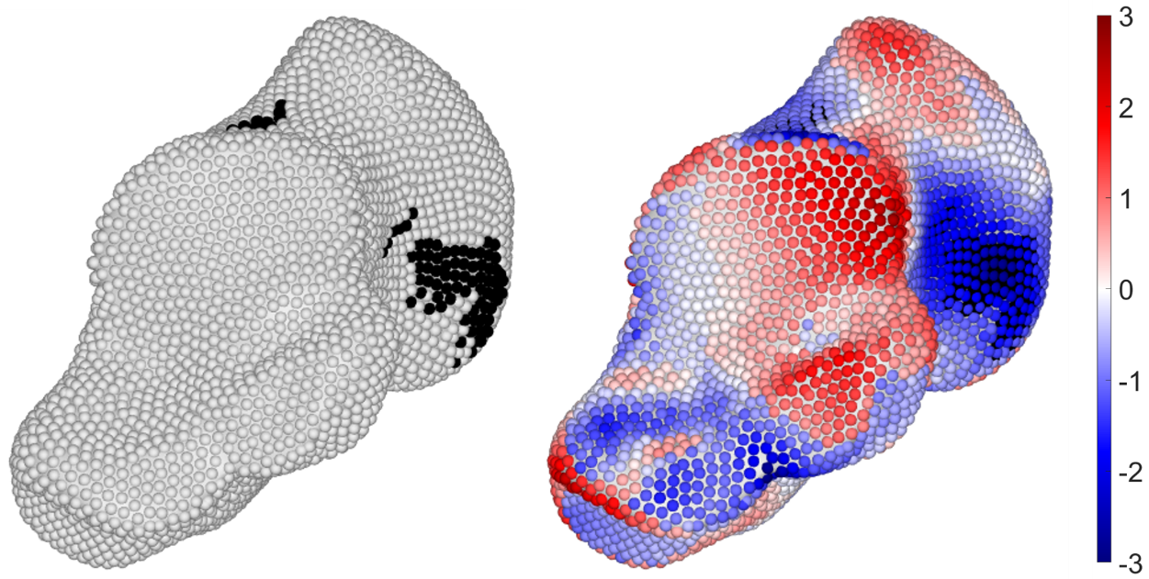

* 1. **Running the script: User Inputs**
* Enter the name of the comparison. The script will automatically name any output based on what was selected and performed. However, adding a string here will place this name at the beginning of those names to make them easily identifiable. This is helpful when making figures with different colormaps, viewing perspectives, or simply wanting to keep them separate from other outputs.

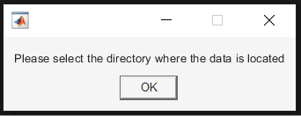

* After selecting the directory, you will be prompted to select the .mat file with the normalized data. This .mat file was created using the JMA_02 script, and the reason for choosing this .mat file is that it has all of the information needed to direct the JMA_04 script to model and particle locations.

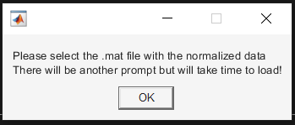

* In the top left corner of the screen, you will be given the choice to select “Group A” or which group you would like to visualize. From the figure below section 12.1 Group A will either have their morphometric difference map visualized as the calcaneus on the right or left based on options you will select. With red denoting distances projecting outward from Group B, and blue denoting distances projecting inward toward Group B. The morphometric difference distances are calculated between the two correspondence particles and checked for direction based on which direction they pass through the Group B surface mesh. Note that particles with a black ring around them indicate statistically significant particles from the multivariate Hotelling *T­­2* test.

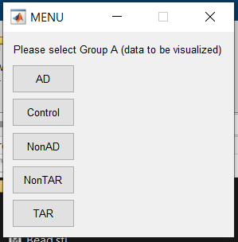

* After selecting Group A, you will be asked to select Group B.

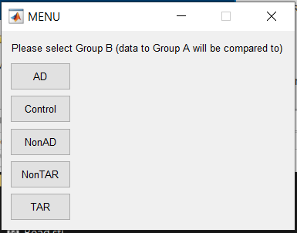

* The next prompt “Change figure settings” allows you to an extent customize your figure.
  + Colormap Limits: Lower and Upper limit (set automatically from the largest distance)
  + Glyph Size: Changes the size of the correspondence particle bead and discs
  + Viewing Perspective: If you know what viewing perspective you need you can enter it here. Otherwise, you can load it from a previously saved figure setting (from JMA_03)
  + Load previous viewing perspective? Loads a figure setting .mat file saved from JMA_03
  + Glyph Color (Default): This will set the bead color if the particle is NOT statistically significant. Only applicable if the “Include distance maps?” box is not checked.
  + Glyph Color (Significant): Sets the bead color if the particle IS statistically significant. Only applicable if the “Include distance maps?” box is not checked. Note that the discs are removed in this instance, and that the color will reflect the underlying statistical results instead.
  + Include distance maps? This box is checked by default and will have the red and blue morphometric distance maps using the Colormap Limits as the colormap bounds. Unchecking or unselecting this box will create a figure similar to the calcaneus on the left from 12.1.

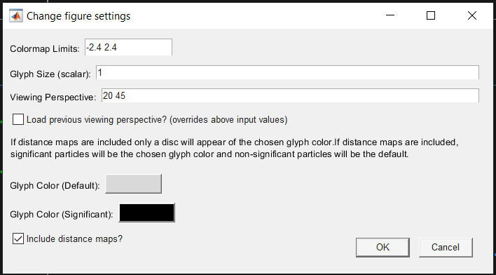

* Lastly it will generate two figures. The first (below) will be Group A with the mapped data, and second (second below) will be Group B with no mapped data but within the same field of view and viewing perspective. It generates both so you have options for your figure creation. The Group B figure includes the colormap and this is specifically to keep a consistent aspect ratio and zoom between both figures. Without it the figure of Group B will have much larger bone making it more difficult to create consistent figures.

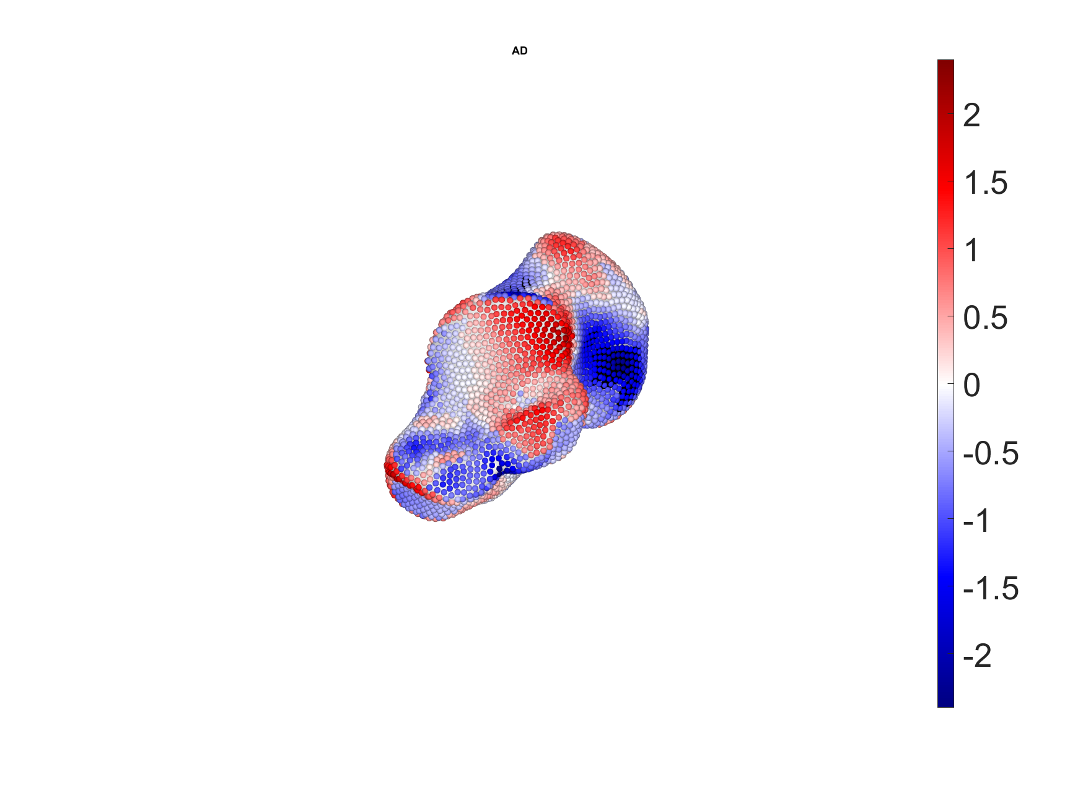

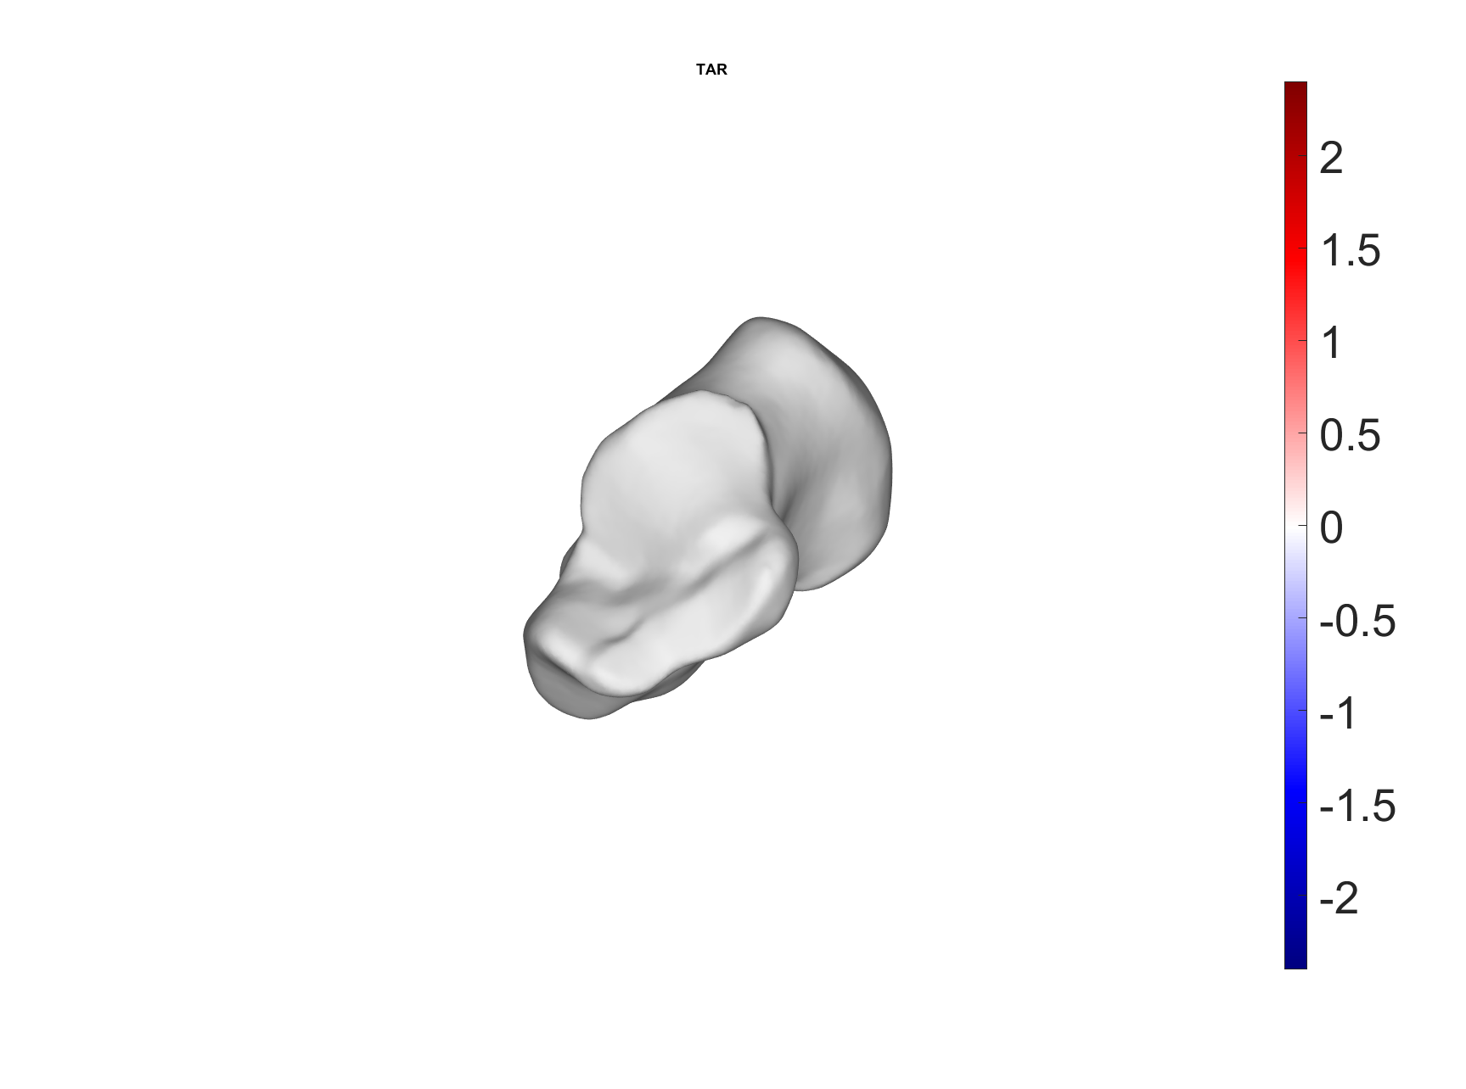

* Depending on how you want to create your figures you may need to run the JMA_04 script multiple times in order to get all of the perspectives or comparisons that you want. Important note, the viewing perspective in this script dictates the initial view in each figure but more importantly which direction the camera light is coming from. It is set to be head on, so whichever viewing perspective you choose will be the direction of the lighting.

# **Dynamic Visualization – JMA_05**

**JMA_05_Dynamic_Visualization.m**

* 1. **Running the script: User Inputs**

The JMA_05_Dynamic_Visualization.m script creates videos for visualizing the joint results of specific participants during the dynamic activity. You will need to select the participant specific .mat file created from the JMA_01 script.

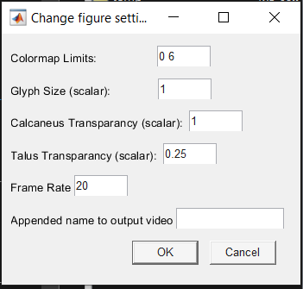

* 1. **Changing figure settings**
     1. Colormap Limits – sets the limits for the joint space distance
     2. Glyph Size (scalar) – changes the size of the visualized beads
     3. Bone_1 Transparency (scalar) – sets the transparency of the bone of interest (data mapped to)
     4. Bone_2 Transparency (scalar) – sets the transparency of the opposing bone
     5. Frame Rate – the frame rate for the video
     6. Appended name – adds an additional name to the output video

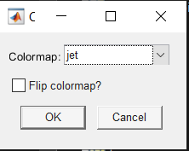

* 1. **Colormap choice**
     1. Colormap – select or enter name of the colormap to be used
     2. Flip colormap? – check the box to flip the colormap

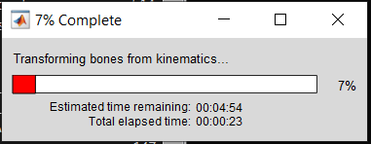

* 1. **Transforming bones from kinematics…**
     1. This section of the code loads the data for each frame and generates the 3D models for visualization. Effectively, in order for the colormap to remain consistent and render quickly during visualization of the video the 3D objects need to be created beforehand and then viewed separately.

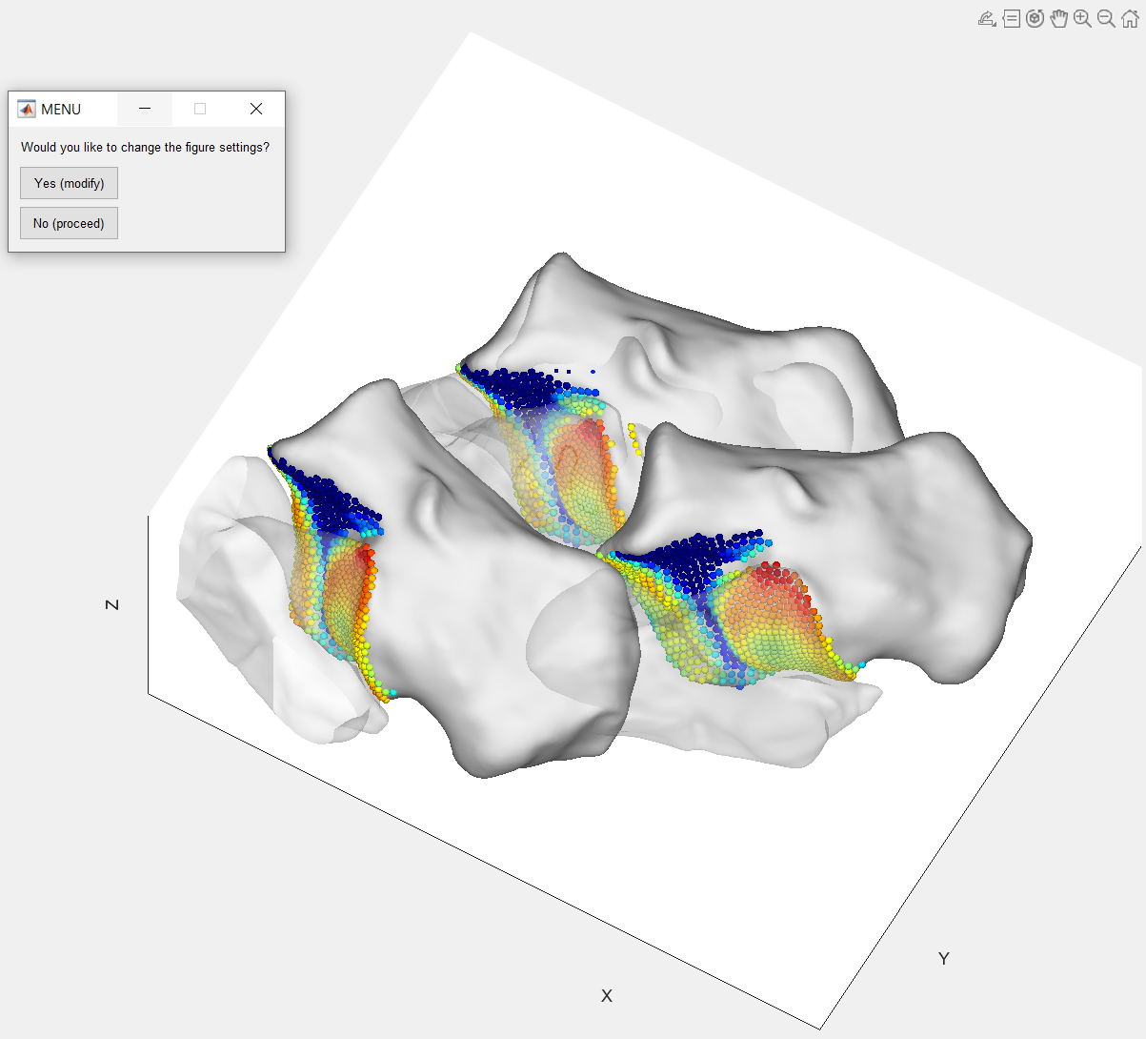

* 1. **Change figure settings:**

This figure attempts to show the envelope of movement for the videos. There are three sets of bones which include the first tracked frame, a middle-tracked frame, and the last tracked frame. From this example we see that the bones are sitting on their side and facing away from us. So we will select “Yes (modify)” from the menu.

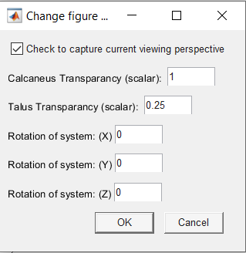

* 1. **Change figure settings:**

Like previous figure settings user inputs, you can change options here. If the viewing perspective button is selected (checked) then it will use the viewing perspective that the figure is last moved to. So, rotate and zoom the figure where you would like before selecting OK. If you would like to make further changes, no worries you will be asked if you would like to make modifications again. Additionally, to get the bones in a position that works best for viewing you can type in a number of degrees to rotate the bones about either the X, Y, or Z axis. Again, you can try a rotation and if you are not happy with it you can modify it further. Just select “Yes (modify)” and make changes until you are content with the visualization. Once you select “No (proceed)” it will keep the viewing perspective and rotations and create a video file for the entire dynamic activity. This is helpful in being able to visualize and interpret individual participant’s joint space distance measurements during the dynamic activity.

* 1. s

# **Frequently Asked Questions – FAQs**

* Q: Why are particles missing from the figure?

A: Could be for a variety of different reasons:

1. Depending on the percentage of participants that you selected it may not have enough participant’s data there to be included in the analysis (most often the case)
   1. This could be due to one or more participant’s morphology affecting the coverage area identification around that particle
   2. The particle in question is outside of the distance thresholds for one or more participants (or potentially bone on bone overlap)
2. Poor correspondence and gaps within the distribution of the correspondence particles

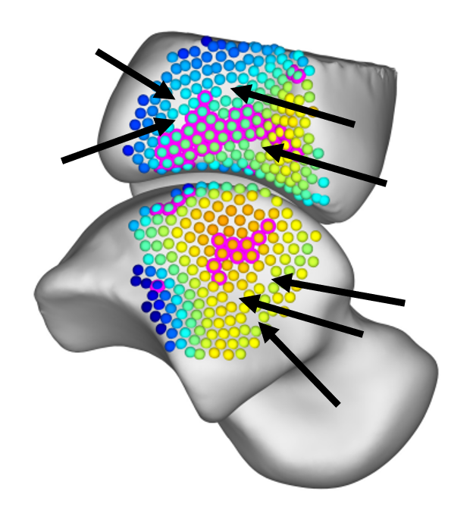

* Q: How do I run a Statistical Shape Model?

A: Perfectly good question, ShapeWorks is an open-source tool that is simple and easy to use to get started with. <https://www.sci.utah.edu/software/shapeworks.html>

* Q: Can I run multiple scripts at the same time?

A: With the parallel computing, you will not be able to as it will set aside “workers” to be dedicated for use within the script. This will also affect other desktop applications, so it is suggested to not do anything major while the scripts are running.

* **If you have your own questions, please reach out!** [rich.lisonbee@utah.edu](mailto:rich.lisonbee@utah.edu)

|  |  |  |
| --- | --- | --- |
| **Revision Date** | **Revision Author** | **Revision Description** |
| 2023-08-23 | R. J. Lisonbee | Drafted |
| 2024-02-08 | R. J. Lisonbee | Updated with JMA_04 |
|  |  |  |
|  |  |  |
|  |  |  |
|  |  |  |
|  |  |  |
|  |  |  |
|  |  |  |
|  |  |  |
|  |  |  |
|  |  |  |
|  |  |  |
|  |  |  |